<https://microsoftlearning.github.io/AI-102-AIEngineer/Instructions/01-get-started-cognitive-services.html>

Provision a Cognitive Services resource

Azure Cognitive Services are cloud-based services that encapsulate artificial intelligence capabilities you can incorporate into your applications. You can provision individual cognitive services resources for specific APIs (for example, **Language** or **Computer Vision**), or you can provision a general **Cognitive Services** resource that provides access to multiple cognitive services APIs through a single endpoint and key. In this case, you’ll use a single **Cognitive Services** resource.

1. Open the Azure portal at https://portal.azure.com, and sign in using the Microsoft account associated with your Azure subscription.
2. Select the **＋Create a resource** button, search for *cognitive services*, and create a **Cognitive Services** resource with the following settings:
   * **Subscription**: *Your Azure subscription*
   * **Resource group**: *Choose or create a resource group (if you are using a restricted subscription, you may not have permission to create a new resource group - use the one provided)*
   * **Region**: *Choose any available region*
   * **Name**: *Enter a unique name*
   * **Pricing tier**: Standard S0
3. Select the required checkboxes and create the resource.
4. Wait for deployment to complete, and then view the deployment details.
5. Go to the resource and view its **Keys and Endpoint** page. This page contains the information that you will need to connect to your resource and use it from applications you develop. Specifically:
   * An HTTP *endpoint* to which client applications can send requests.
   * Two *keys* that can be used for authentication (client applications can use either key to authenticate).
   * The *location* where the resource is hosted. This is required for requests to some (but not all) APIs.

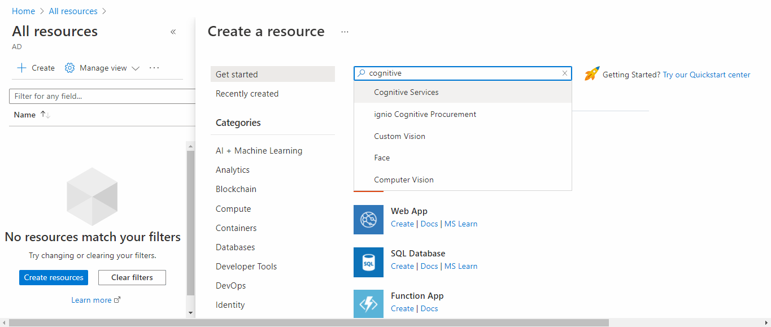

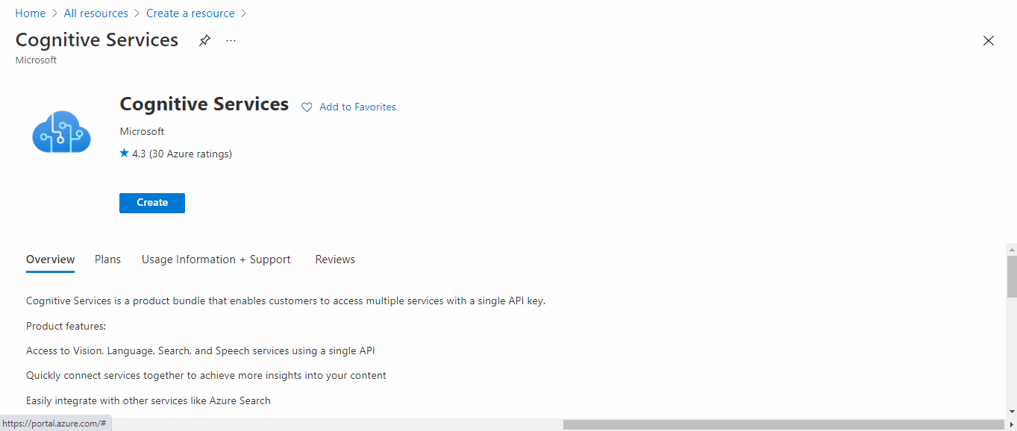

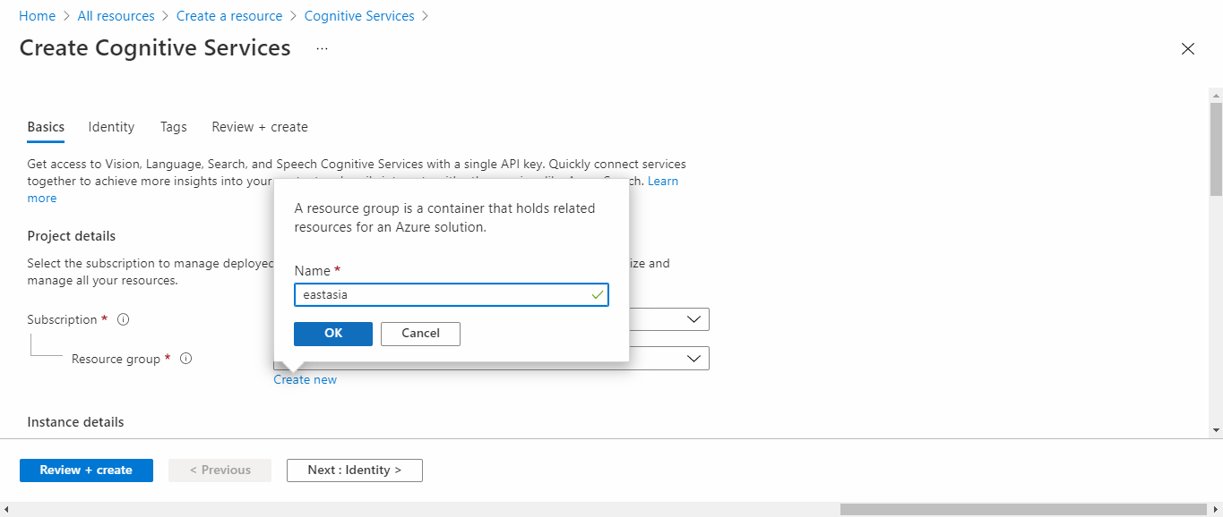

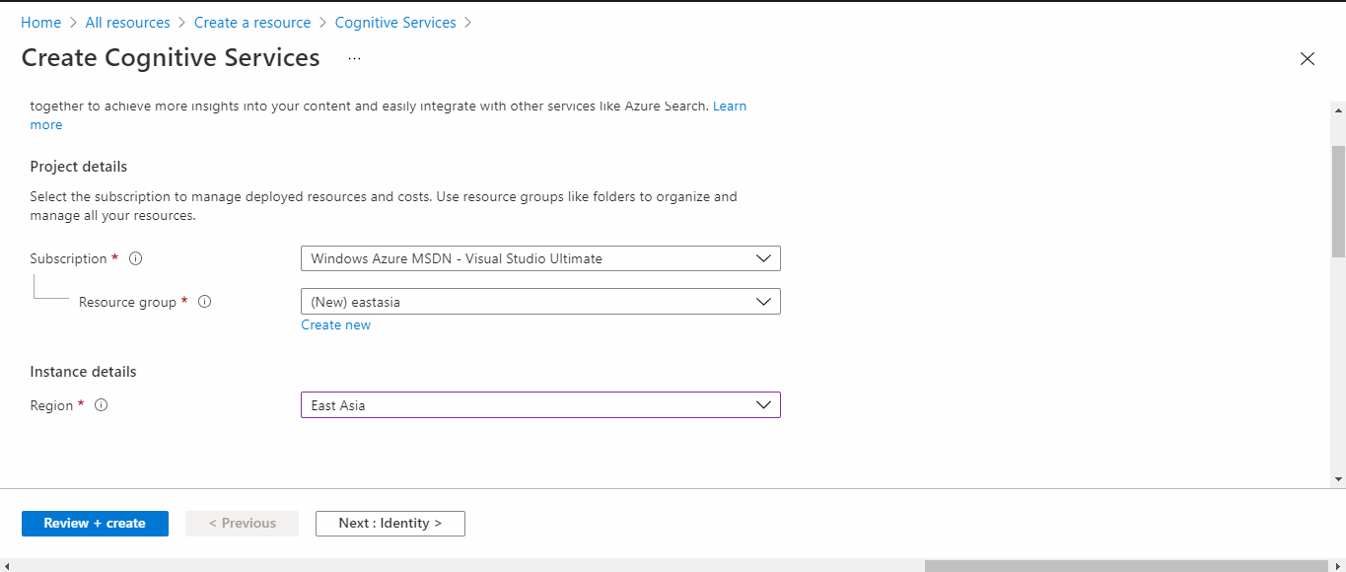

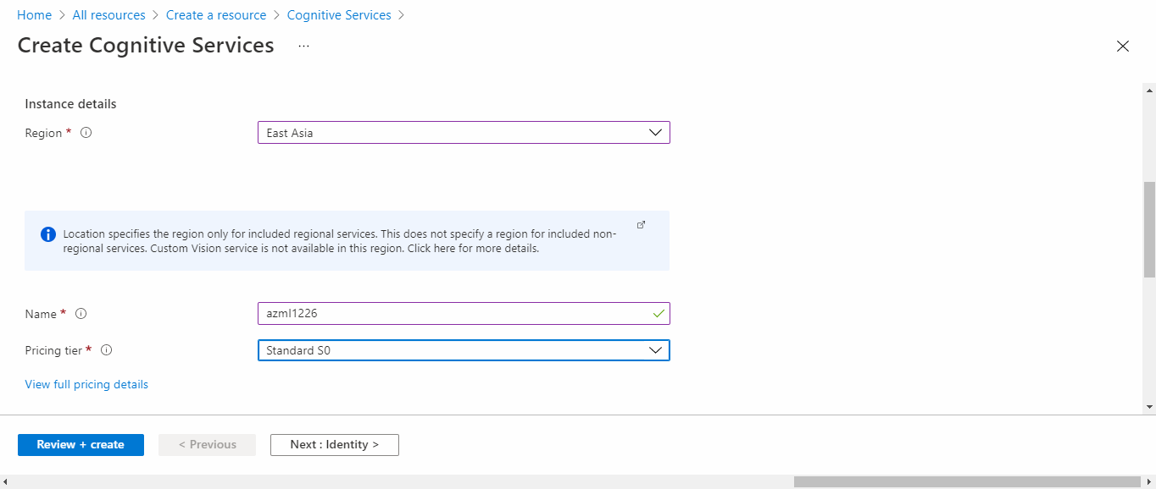

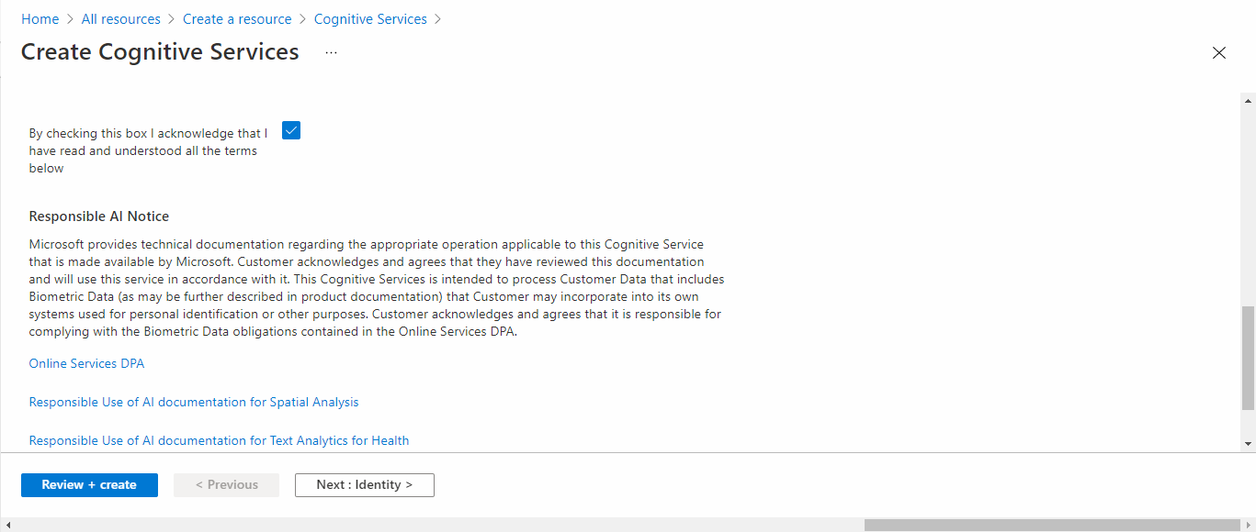

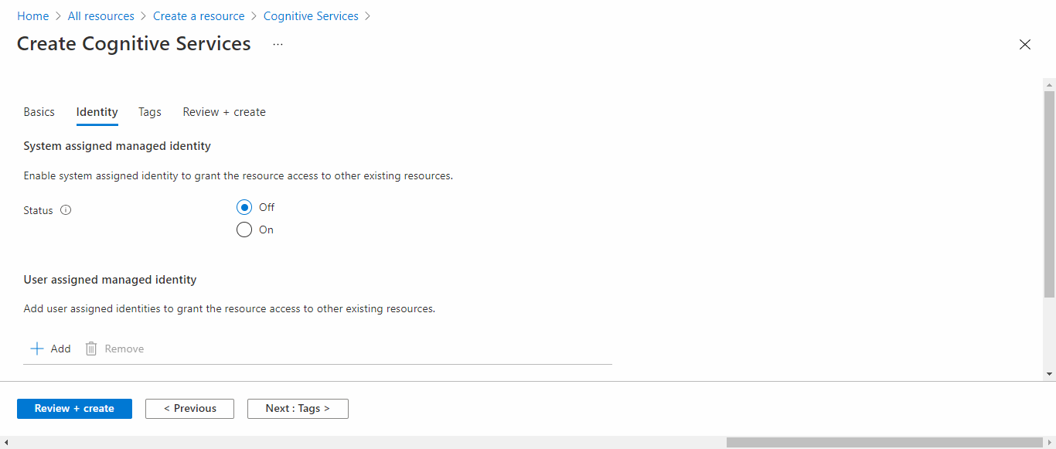

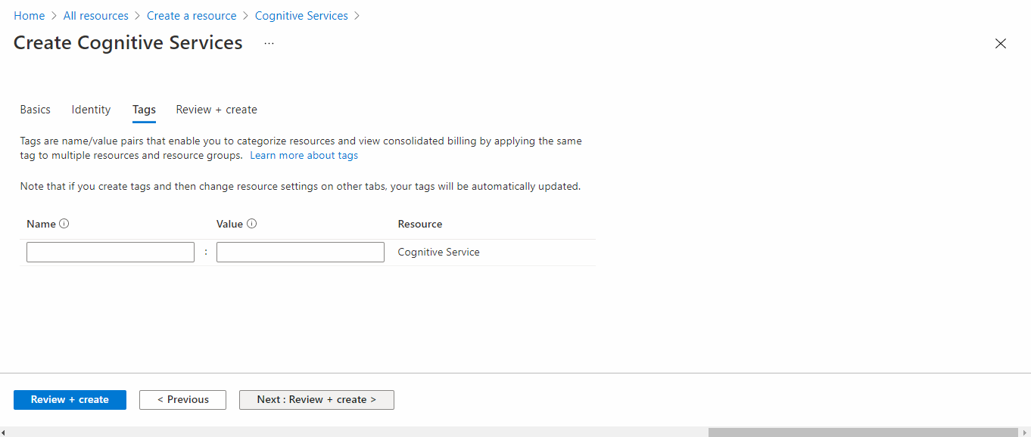

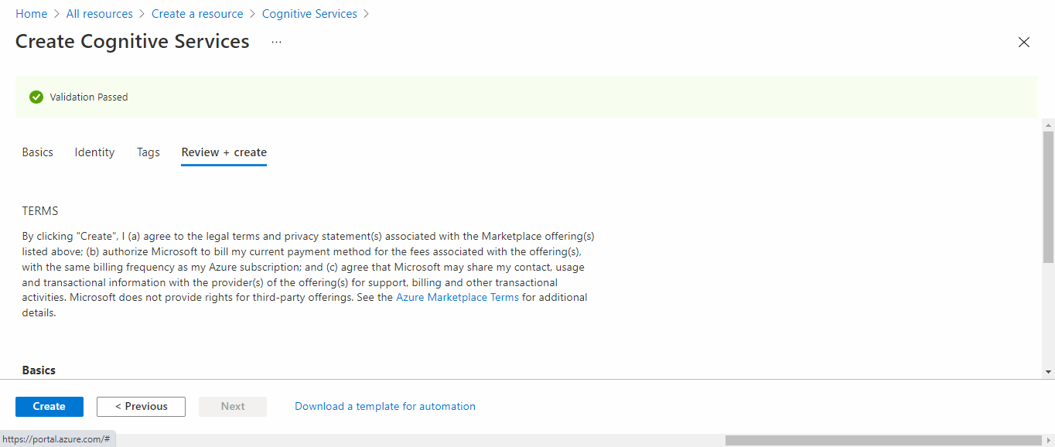

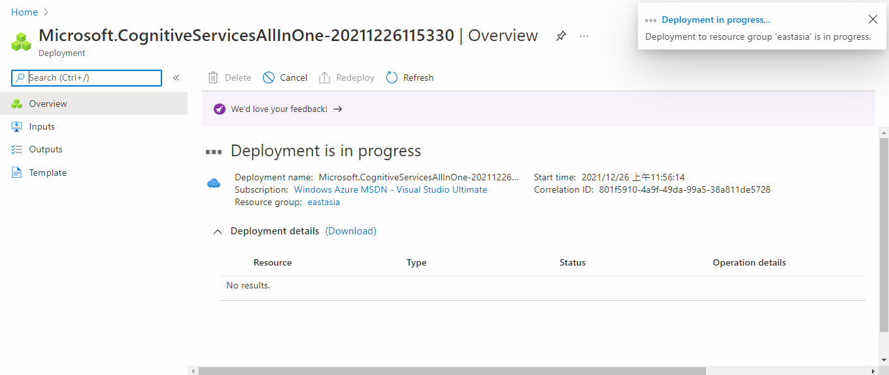

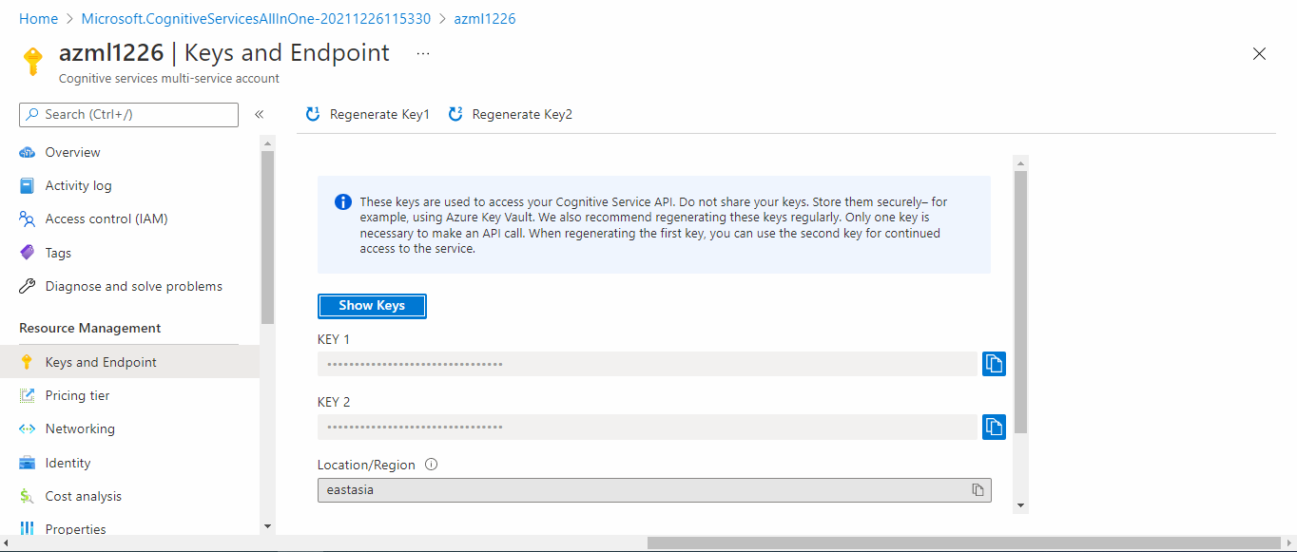

~~5290f8f052fb4e2c8e5274224929f742~~

~~eastasia~~

~~https://azml1226.cognitiveservices.azure.com/~~

d294986eff75428898f84f7d6b80f694

eastasia

https://azml0608.cognitiveservices.azure.com/